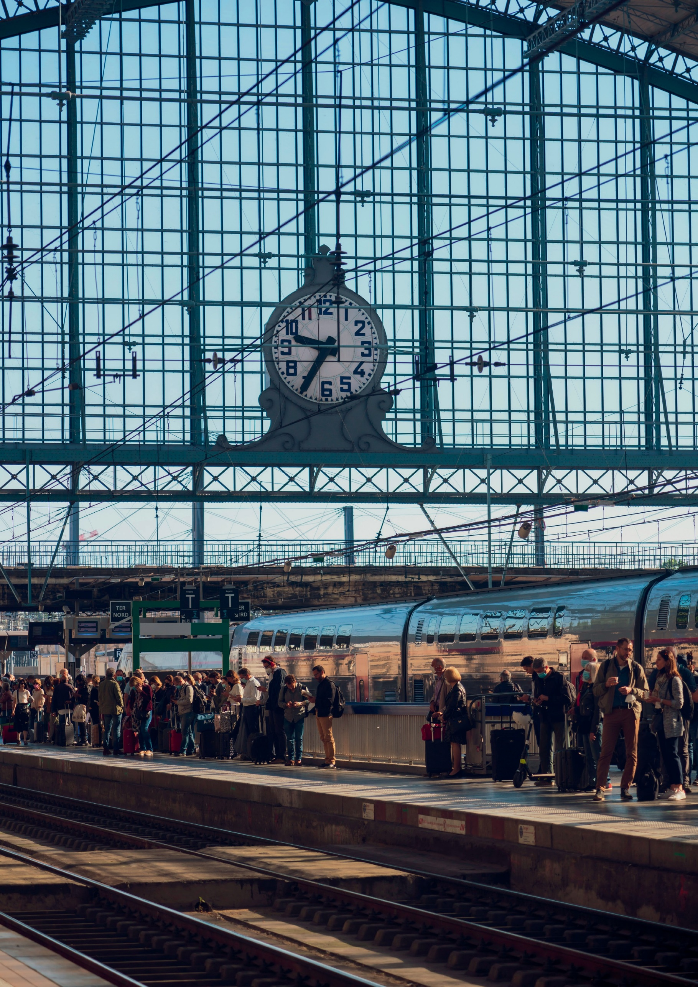

QUESTIONNAIRE FOR CANDIDATES IN THE EUROPEAN ELECTIONS
8 AND 9 JUNE 2024
Report by the TDIE Scientific Council
April 2024

To make it easier to compile the answers that will be published on the Internet before the ballot, please provide some information about your list:

Name of the list

Head of the list: Mr/Ms (first name + surname)

Parties and movements supporting the list

Logo/

Bordeaux railway station

EUROPEAN PARLIAMENT ELECTIONS JUNE 2024
2
The future of Europe: transport
For the attention of the heads of lists of candidates for the European elections in France on 9 June 2024

TDIE wishes to contribute to identifying the diversity of issues at stake in a European transport, mobility and logistics policy in order to ensure that it occupies the place it deserves in the work of French MEPs during their 2024-2029 term of office.

Although the European Parliament does not initiate legislation; although it shares the role of joint legislative body with the Council of the European Union; and although transport is a competence shared between the Union and its Member States, European transport policy represents a major challenge for our continent in view of the efforts required to achieve carbon neutrality by 2050. What can be done, how can it be done and what resources are needed to succeed?

This is the purpose of the questionnaire prepared by the TDIE Scientific Council for the lists of candidates in the European elections in France: to encourage the expression of well-founded proposals and guidelines that include the recognition of socio-economic, territorial and technological facts, trends and dynamics together with the distribution of institutional and political prerogatives within the European Union.

TDIE would like to share your proposals with as many people as possible at a time when they can be read and analysed in the best possible conditions. We will be publishing the answers during the week of 20 May, so we would be grateful if you could send us your reply by e-mail (to secretariat@tdie.eu) by 16 May at the latest. This document has been sent to you in Word format below so that you can easily enter your answers and so that we can publish all answers in the same format.

NB: the questions are numbered from 1 to 18. Some of these questions include sub-questions to make it easier to identify the range of alternatives and factors for orientation. If you wish, you can answer in internally coherent paragraphs in relation to each question.

If you have any queries, please contact the TDIE team (Pierre Van Cornewal, Managing Director: + 33 1 44 13 31 84 or pvancornewal@tdie.eu).

Philippe Duron and Louis Nègre, joint chairmen of TDIE

EUROPEAN PARLIAMENT ELECTIONS JUNE 2024
4
The future of Europe: transport

WHAT DO YOU EXPECT FROM THE EUROPEAN UNION IN TERMS OF TRANSPORT POLICY?

- Transport is a competence shared between the European Union and the Member States (Article 4 of the Treaty on the Functioning of the European Union). What do you expect from the European Union in terms of transport policy? What do you see as the challenges for transport policy over the next few years?

Answer……………….

- To implement the Green Deal guidelines, the European Union has adopted legislation more ambitiously than in the past, setting a bold target for 2050 (reducing transport GHG emissions by 90% by 2050 from 1990). The Fit For 55 legislative package, which aims to meet the 2030 climate target (reduction of GHG emissions in the EU by at least 55%), has set a number of specific targets for transport. The legislative texts adopted during the 2019-2024 mandate cover the diversity of modes of transport - road, air, sea, rail and inland waterways - and relate to infrastructure policy (planning with the Trans-European Transport Network (TEN-T), charging for the use of road infrastructure with the revision of the Eurovignette directive), standardisation and regulation policy (limiting emissions from new heavy-duty road vehicles, banning the sale of new light internal combustion-engine vehicles by 2035), carbon pricing (Emissions Trading System market) and mobilising industry (to deploy gigafactories for manufacturing electric batteries). Do you think these guidelines are relevant and appropriate from a European perspective to meet the challenges of decarbonising transport? Should these guidelines be maintained or even extended? If so, how? If not, what do you think needs to be called into question?

Answer……………….

- On 6 February 2024, the European Commission published a communication in preparation for setting the climate targets for 2040. These targets will be set out in the legislative proposals on which you will be asked to vote if you are a member of the European Parliament. In this communication, the European Commission envisages raising the EU's GHG emissions reduction target to -90% by 2040 compared to 1990. It emphasises that the transport sector is where the most effort needs to be made, and sets out a number of specific action proposals (see box below). However, it does not set a climate target for transport by 2040.

  - Do you think the Parliament should debate the priorities and targets to be met with regard to the various European transport policy factors? In this context, do you think the Commission should update the December 2020 Sustainable and Smart Mobility Strategy? Do you have any views on the tools used to monitor and evaluate European transport policies?
  - To achieve the objective of a significant reduction in GHG emissions from transport, the European Commission has drawn up a list of the factors and actions likely to affect them. Do you consider any particular actions to be priorities or more or less effective or necessary than others? Which ones?
  - Should the Commission include other actions or guidelines among the levers that it has identified to date to decarbonise the transport sector? Which ones?

Answer……………….

QUESTIONNAIRE

What path should be taken towards carbon neutrality for the European Union by 2050? Action envisaged by the Commission for decarbonising transport (communication of 6 February 2024)
In its December 2019 communication on the Green Deal for Europe, the European Commission stated that no less than a 90% reduction in transport sector emissions by 2050 would be sufficient to put Europe on the path to climate neutrality. According to the communication of 6 February 2024, the implementation of the measures in the Fit For 55 package combining carbon pricing and technological solutions and the development of an efficient, interconnected multimodal transport system (to which the revision of the TEN-T should contribute) will reduce emissions from the transport sector by 2040 by almost 80% compared to 2015.

The Commission's emissions projections vary depending on the mode of transport:

➤ For road transport, CO₂ emissions reductions are set to accelerate with the deployment of zero-emission vehicles encouraged by European regulations¹: the share of battery-electric and other zero-emission vehicles is expected to reach more than 60% for cars, more than 40% for vans and almost 40% for heavy goods vehicles by 2040. The Commission is also proposing to tighten up emission standards for new heavy goods vehicles in order to achieve a 100% reduction by 2040 (the target in force at the end of the 2019-2024 mandate is 90%). In addition, carbon pricing (ETS 2) and updating fuel policies² will help decarbonise the vehicle fleet already on the road.

➤ Sea and air transport emissions will be reduced with the extension of the EU ETS to sea transport, the phasing out of free allowances in aviation and the targets set in the FuelEU Maritime and RefuelEU Aviation regulations adopted in 2023. In 2026, the Commission will assess the appropriateness of extending carbon pricing to aviation and sea transport, for example to cover business aviation and vessels of under 5,000 tonnes. Aviation and sea transport should have priority access to alternative low- or zero-emission fuels (including synthetic fuels and advanced biofuels) over sectors that have other decarbonisation solutions such as direct electrification. Special measures will have to be set up to ensure that sufficient raw materials are available for the production of sustainable alternative fuels.

➤ Increased use of rail transport by means of revising the TEN-T policy and making better use of infrastructure capacity may also contribute to decarbonising the transport sector, as may the development of digital solutions, the greening of freight transport³ and the promotion of sustainable and affordable urban mobility (improving public transport provision and developing active mobility).⁴

- - Regulation to end the sale of new light-duty vehicles with internal combustion engines in the EU by 2035 and regulation on tightening CO₂ emission performance standards for new heavy goods vehicles (90% reduction in emissions by 2040).
- - Revised Renewable Energy Directive: for the transport sector, the text stipulates a reduction of 14.5%
in the carbon intensity of transport by 2030, or at least 29% renewables in the sector's energy consumption by 2030.
- - Draft regulation on the use of railway infrastructure capacity in the Single European Railway Area (still under negotiation).
- - "Greening Freight" legislative package published in July 2023: draft regulation establishing a harmonised framework for the accounting of greenhouse gas (GHG) emissions from freight and passenger transport services,
(CountEmissions EU), draft regulation on the use of railway infrastructure capacity in the single European railway area, revision of the 1996 Weights and Dimensions Directive and revision of the Combined Transport Directive.

EUROPEAN PARLIAMENT ELECTIONS JUNE 2024
5
The future of Europe: transport

  - The economic and industrial transport sector is one of the strengths of European know-how and competitiveness: engineering and public works for all infrastructure modes, various technological and technical systems (infrastructure equipment and operating systems, production of vehicles for various modes of transport, i.e. road, rail, air, inland waterways and sea).

    - In your opinion, is the objective of decarbonising transport a factor for innovation and competitiveness for EU industry, or a risk factor?
    - As a corollary to the objective of decarbonising the transport sector, should the European Union significantly develop its industrial and energy strategy and objectives?

Answer……………….

  - The defence and security of the European continent is now a major objective of the European Union. What role do you think transport can or should play in achieving this objective in terms of infrastructure, the transport industry, transport safety, data management and research?

Answer……………….

QUESTIONNAIRE

EUROPEAN FUNDING AND TRANSPORT INFRASTRUCTURE

  - The European Commission is already considering what European funding should be set up after 2027, particularly for the transport sector. The financial and legislative proposals for the future Multiannual Financial Framework (MFF) after 2027 will be published in 2025 in the context of a very tight budget (due to the obligation to repay the NextGenerationEU loan from 2028, the funding needed for aid to Ukraine, the prospect of the next enlargement to include Ukraine and the Western Balkans, the priority to be given to defence funding, etc.). The Commission also wants to encourage synergy between transport and energy in order to adopt a more systemic approach to decarbonising the entire industrial process. In this context:

    - Will you support the introduction of a new European loan, as France has called for, but which is opposed by several Member States?
    - In your opinion, should the Commission (via the European Climate, Infrastructure and Environment Executive Agency) continue to intervene mainly through direct management to finance infrastructure, or are you in favour of a model that would give the Member States greater latitude in allocating European funds (such as the Recovery and Resilience Facility, with the development of national plans)?
    - Do you think that the future Connecting Europe Facility (CEF) should give priority to funding cross-border TEN-T transport infrastructure, as recommended by the corridor coordinators in their April 2024 report, or do you think that CEF support is still needed for other strategic national infrastructure integrated into European corridors (examples in France include the new Paris-Normandy line, the new Provence-Alpes-Côte d'Azur line and the Bordeaux-Toulouse high-speed line)?

Answer……………….

  - In the revised version of the TEN-T regulation, the provisions relating to urban nodes have been strengthened. These provisions were a European regulatory incursion into local urban mobility policies and were among the European Parliament's priorities.

    - In your opinion, should the EU intervene in urban mobility on the sub-national level in terms of regulations and funding, or do you believe that the principle of subsidiarity should prevail? Should the regional metropolitan express services (SERMs) projects be eligible for European funding?
    - Should the EU legislate and set specific objectives in the area of active mobility, in particular to support the development of cycling as part of everyday mobility? See the European Declaration on Cycling adopted by the Parliament and the Council that was signed by the Commission and published in the OJEU on 3 April 2024.

Answer……………….

FOLLOW-UP TO THE EUROPEAN LEGISLATIVE AGENDA AND MODAL APPROACHES

  - The fourth European rail package of2016 calls for the development of interoperability between national rail networks through the deployment of technical standards such as the European Railway Traffic Management System (ERTMS). This objective is also being pursued under the TEN-T policy. However, the rate at which rail networks are being upgraded is highly uneven, and the process of making rail services more attractive is being hampered by the state of the major networks (particularly in France and Germany) and by the lack of rolling stock. In his report on the future of the single market presented to the European Council on 18 April 2024, Enrico Letta stressed the need to step up efforts on the railways by increasing funding, developing the high-speed rail network and accelerating the deployment of technologies that contribute to network efficiency (ERTMS, Digital Automatic Coupling and Digital Capacity Management). Should the European Union prepare a new European rail deal with a fresh package of measures to encourage the development of rail services and traffic? How?

Answer……………….

  - Two of the texts in the Fit For 55 package include binding standards for the road vehicle industry (cars and heavy goods vehicles) and provide for review clauses in 2026 and 2027 (the regulation establishing a ban on the sale in the EU of new light vehicles with internal combustion engines by 2035 and the regulation requiring a 90% reduction in CO₂ emissions from new heavy goods vehicles in the EU by 1 January 2040, and a 100% reduction in emissions from new city buses by 2035): how will you position yourselves as joint legislators with regard to these revisions?

Answer……………….

  - Intra-European air transport and, since 1 January 2024, intra-European and international sea transport (for half) have been integrated into the European carbon quota market. The road transport sector (passengers and goods) should be covered by a second carbon market to be phased in from 2027 (also known as "ETS 2").

    - Are these measures enough? Should we go further and, if so, how? What do you expect from the introduction of these carbon quota markets for the transport sector?
    - The introduction of ETS 2 is accompanied by the introduction of the Social Climate Fund, designed in particular to mitigate the impact of the ecological transition in the transport sector on the most vulnerable households and businesses. Do you think that this fund, managed by setting up a dedicated national plan in each Member State, is a satisfactory tool for meeting this challenge? Do you think that other European measures are needed to ensure social equity in the decarbonisation of transport in line with the EU's ambitions?

Answer……………….

  - How can we strike a balance between environmental concerns and the need to maintain the competitiveness of the European airline industry? Should the European Union continue and step up its efforts to encourage the decarbonisation of aviation fuels? Should Europe develop an e-fuel/e-kerosene industry?

Answer……………….

QUESTIONNAIRE

  - The EU has become aware of its vulnerability in global supply chains. It has begun to equip itself with instruments to protect itself and stay vigilant in the face of foreign investment and unfair competition from third countries. For example, an anti-subsidy investigation into imports of battery electric vehicles (BEVs) from China was opened in October 2023.

    - In your opinion, is this a good thing? Should we go further? Do you endorse the European political concept of "open strategic autonomy"¹ established under the Spanish Presidency of the Council of the European Union in the second half of 2023?
- Faced with the American Inflation Reduction Act (IRA) or Chinese practices, do you think the European rules for supporting our industry (State aid rules, Important Projects of Common European Interest - IPCEI) are appropriate? Should they be changed, for example to encourage the emergence of "European champions", particularly in the rail industry, along the lines of the aeronautics industry)?
- Do you think it is appropriate or necessary to move towards a "Buy European Act", the premises for which were laid down in the Net Zero Industry Act regulation?

Answer……………….

FREIGHT AND LOGISTICS

  - At the end of 2023, the European Commission published a draft revision of the Combined Transport Directive, which changes the approach in force until now (it defines combined transport operations that can be supported by national measures as operations that reduce negative externalities by at least 40% compared with road-only operations. The previous definition of a combined transport operation was based on the minimum distance (100 km) of its non-road component). Although the outgoing European Parliament has published a working document, the Parliament's position will be established during the next mandate. Can the obstacles to the development of combined transport be removed by European legislation? Do you feel that the draft text proposed by the Commission is ambitious and effective enough?

Answer……………….

  - EU policies designed to support multimodal transport and intermodal solutions for goods (Combined Transport Directive, regulation on rail freight corridors, European multimodal corridors and inland ports and terminals and the development of traffic on inland waterways) have so far had little tangible impact. Do you have any proposals for making better use of maritime and inland port, rail and river infrastructures? Should the European Union introduce more incentives for shippers to develop the modal transfer of goods to rail and inland waterways (within a network of inland ports) or to short sea shipping? If so, which ones?

Answer……………….

- - The aim of this idea is to "promote a more competitive and resilient Europe in the face of global technological and geopolitical change (...) without resorting to protectionism or abandoning the European values of competitiveness, sustainability and cohesion" - see https://spanish-presidency.consilium.europa.eu/en/programme/open-strategic-autonomy-spanish-presidency-eu-council-resilient-eu2030/

WHAT SOCIAL POLICY SHOULD BE ADOPTED AND WHAT SHOULD THE TRAINING GOALS BE? WHAT ARE THE RESEARCH AND DEVELOPMENT CHALLENGES FOR THE TRANSPORT SECTOR?
  - In the transport sector, the single market has revealed major social disparities between countries. For example, a de facto division of labour between countries has been established in road transport. In a restricted labour market with unattractive transport jobs, it would seem appropriate to bring the policies of the Member States into convergence to provide a new social impetus. Enhancing qualifications through training and harmonising job descriptions could be a European project.

    - Do you think the European Union should start thinking about the changes in jobs and skills needed to keep pace with changes in logistics and mobility practices, the need for sustainable mobility and the digital and energy transitions? Do you think it would be appropriate for the EU to help speed up and harmonise national approaches? For example, could it implement a process for validating initial and continuing vocational training and its mutual recognition at Community level?
    - With a view to further enlargement of the EU to include countries with lower labour costs, do you think the EU should strengthen its legislation to counter social dumping in the transport sector, particularly in road and sea transport? How can the necessary controls be implemented?

Answer……………….

  - Decarbonising transport calls for significant innovation and research and development efforts in many areas, from technology to the human and social sciences. The European Union has set up Framework Programmes for Research and Technological Development, of which Horizon Europe, which covers the period from 2021 to 2027, is the ninth.
With a budget of €95.5 billion, it is the largest of the European sectoral programmes in terms of volume. Of the six main areas (“clusters”), one is dedicated to mobility (the climate, energy, and mobility cluster). Do you think the EU's support for mobility research and development is well-calibrated? Should the dynamics supported by the Horizon Europe programme be continued or clarified for the next Framework Programme for Research and Technological Development (2028-2034)? What do you think should be the European Union's research and development priorities for transport (decarbonisation, automation/AI or other; fundamental research, technological innovation, support for experimental innovation, social sciences)?

Answer……………….

QUESTIONNAIRE

WHAT KIND OF POLITICAL SUPPORT SHOULD THERE BE FOR TRANSPORT AT THE COMMISSION AND IN THE EUROPEAN PARLIAMENT?

  - The challenges involved in decarbonising transport are increasingly cross-cutting: they affect energy policy, the internal market and industry.

    - How can we ensure that transport, which is the EU's biggest emitter of greenhouse gases, is central to the concerns of the new College of European Commissioners?
    - If you sit in the next European Parliament, you will be required to audition the candidates for Commissioner posts. What do you expect from the next European Transport Commissioner?

Answer……………….

  - In preparing for the next mandate, have you entrusted the issue of transport and its various issues to one or more of your running mates? Are any candidates who are in an eligible position preparing themselves to speak in particular on the complex issues of European transport policy, which are now covered by various committees: primarily the TRAN (transport and tourism) committee, but increasingly the ENVI (environment) and ITRE (industry) committees?

Answer……………….

